REAL ESTATE REGULATORY AUTHORITY HIMACHAL PRADESH
No. /HP/RERA-(A)-3-2/ Regulations/2023/Vol-1- Shimla-2, 11th January, 2024

NOTIFICATION
In exercise of the powers conferred by section 85 of the Real Estate (Regulation and Development) Act, 2016 (Act No. 16 of 2016) and all other powers enabling it on that behalf, the Himachal Pradesh Real Estate Regulatory Authority, hereby makes the following Regulation to amend the Himachal Pradesh Real Estate Regulatory Authority Periodical Progress Report (Quarterly Progress Report/Annual Progress Report), Regulation No. 4 of 2020 notified vide Notification No HP/RERA-(A)-3-2/ Regulation /2020Vol-1/553 dated 18-12- 2020 and published in the Official Gazette of Himachal Pradesh on 21-12-2020, namely:-

- Short title and commencement---(1) This Regulation may be called the Himachal Pradesh Real Estate Regulatory Authority Periodical Progress Report, (Quarterly Progress Report/Annual Progress Report), Amendment Regulation No. 4 of 2024.
(2) This Regulation shall come into force from the date of its publication in the Official Gazette of Himachal Pradesh.

- Amendment in Format of Quarterly Progress Report (QPR-2) -
  - After Clause 5 of i.e. Status of completion of Infrastructure Development of the Himachal Pradesh Real Estate Regulatory Authority (Periodical Progress reports) Regulation No -4 of 2020(hereafter called as said regulation), the new row i.e. “Overall % of completion of the project till date” above the “Miscellaneous “row shall be inserted.
  - After Clause 5 of i.e. “Summary of allottee and sale report” of the Himachal Pradesh Real Estate Regulatory Authority (Periodical Progress reports) Regulation No -4 of 2020(hereafter called as said regulation), the new row i.e. undertaking stating that “I /we (Promoter name) have issued …… (No. of) Allotment letters in this quarter as
per the format, prescribed by the Authority” shall be inserted.
- Amendment in Chartered Accountant’s Certificate (Annexure-1&2) of Format of Annual Progress Report (APR-2) -
  - In the Annexure -1 i.e. Chartered Accountant’s Certificate of the Himachal Pradesh Real Estate Regulatory Authority (Periodical Progress reports) Regulation No -4 of 2020 (hereafter called as said regulation), below the word (Membership No ), the word “CA Unique document identification number (UDIN No),” shall be inserted.
  - In the Annexture-2, Clause 9.3 i.e. Summary of allottee and sale Report during the financial year of the Himachal Pradesh Real Estate Regulatory Authority (Periodical Progress reports) Regulation No -4 of 2020(hereafter called as said regulation), the new Sr. no. 9.3.1 i.e. undertaking stating that “I /we ……….(Promoter name ) have issued ……( No. of ) Allotment letters in this quarter as per the format, prescribed by the Authority” shall be inserted.
  - After Sr. no. 1.12 of Clause 1 i.e. PARTICULARS OF THE REAL ESTATE PROJECT of the Himachal Pradesh Real Estate Regulatory Authority (Periodical Progress reports) Regulation No -2 of 2020 (hereafter called as said regulation), the new Sr. no. 1.13. i.e. “Overall % of completion of the project till date” shall be inserted.

- Amendment in Chartered Accountant’s Certificate (Annexure-1&2) of Format of Annual Progress Report (APR-3) -
  - In the Annexure -1 i.e. Chartered Accountant’s Certificate of the Himachal Pradesh Real Estate Regulatory Authority (Periodical Progress reports) Regulation No -4 of 2020 (hereafter called as said regulation), below the word (Membership No ), the word “CA Unique document identification number (UDIN No),” shall be inserted.
  - In the Annexture-2 clause 9.3 i.e. Summary of allottee and sale Report during the financial year of the Himachal Pradesh Real Estate Regulatory Authority (Periodical Progress reports) Regulation No -4 of 2020 (hereafter called as said regulation), the new Sr. no. 9.3.1 i.e. undertaking stating that “I /we ………. (Promoter name) have issued …… (No. of) Allotment letters in this quarter as per the format, prescribed by the Authority” shall be inserted.
By order
(Dr. SHRIKANT BALDI),
Chairperson

Annexure-(QPR-2)

QUARTERLY PROGRESS REPORT (QPR-2)

FOR


PLOTTED REAL ESTATE PROJECTS
Quarter for which information is provided Quarter ending (tick mark/Yes)
31st MAR, 2020
30th JUN, 2020
30th SEPT, 2020
31st DEC, 2020
Sr. Description Details Remarks
No.

1 Particulars of the Real Estate Project

Name of Project / Phase Name of the Promoter / Co-Promoter /Company/Firm
Location of the Project Type of Project

(i)
Total
Plotted
Area of Land

Registration No and Validity up to Regn. No. Validity
Up to

Date of Start
Date and number of the approved Order No. Date plan by competent Authority.

2 Association of allottees

Name, of the Association of
Allottees Address
Registration No. & Date of registration certificate


3
Bank and Financial Details
Account No.

Account Name Name of the Bank Address of the bank
IFSC Code No.
Total amount in the account till the end of last quarter
Amount Deposited
Provide details about the source of inflow of cash, and attach extra sheet(s) as
Annexure, if required
Expenditure, if any
Provide details and attach extra sheet(s) as Annexure,if required
Total Amount in the account till the end of quarter under reference
Bank Loan , if any
Is project / part thereof pledged
with any collateral
Bank
or NBFC as
Provide details and attach extra sheet(s) as Annexure , if required
Provide details and attach extra sheet(s) as Annexure , if required
4
Details of the Inventory of the Project
Total Plots
(i)
Plots
Booked Plots
Remaining plots
Mortgage plot(s), if any
(ii)
Please provide a schematic sketch site layout plan on A-4 size of paper showing all
remaining plots with area of each respective plot and mentioning if the same is/are mortgaged (Please fill nil, if no plots in the project


open parking if any
Total Units
Booked Units Remainin
g Units
Mortgage Units(s), if any
- Please provide a schematic sketch site layout plan on A-4 size of paper showing all Garages/ covered parking(s)with area and number of garages/ covered parking(s) and mentioning if the same is/ are mortgaged
- (Please fill nil, if no Garages in the project.)




5 Status of completion of Infrastructure Development Type Status Remark
(Completed/ underway/Yet to
be done/ not in the project)

Boundary wall, gate(s) Roads/paths
Drainage Water Supply Electrification Sewerage Solid Waste Solar
Parking
Rain water collectionand harvesting
Green Area/Playground
Overall % of completion of the
project till date (%)
Miscellaneous
List of Channel Partners( HP RERA Registered Agents), if any

Channel Partner’s Name(Agents) HP RERA Registration No.
i)
ii)
List of Legal cases, if any

Project | Name of Parties | Issue involved | Next date of
 | and Case No. | ( in brief) | hearing and its
 |  | ( in brief) | status

Sr. | Unit | Name of | Date of | Rate (per | Carpet | Sale value | Amount
No | No. | the | booking | Sft.) | Area of | of | collected
 | and | Allottee |  |  | the Unit |  | collected
 | and | Allottee |  | Optional | the Unit | Unit
 | parking |  |  | Optional | and of | Unit
 | parking |  |  |  | and of | including
 | No. if |  |  |  | parking, | including
 | No. if |  |  |  | parking, | parking,
 | any |  |  |  | if allotted | parking,
 | any |  |  |  | if allotted | (Optional)




Annexures:- 1)
Summary of Allottees and Sale Report during the quarter
Total amount
Collected in the quarter for all units
(in Rs. )
Optional
I /we (Promoter name) have issued …… (No. of) Allotment
letters in this quarter as per the format, prescribed by the Authority
6
Latest Site Update through Media Gallery
Please attach photographs of the units and facilities
2)
Place: Date:

(Name of the authorized Signatory of the Project)
Complete Address

Annexure-(APR-2)

ANNUAL PROGRESS REPORT (APR-2)


- PARTICULARS OF THE REAL ESTATE PROJECT
Sr. Particulars Details
No.
  - Name of the Real Estate Project
  - Phase of the Real Estate Project
  - Name of the Promoter Name Name of the co- Promoter(s)
*Add more rows to disclose all co - promoters
  - Total area of the Real Estate Project / Phase
  - Location of the Real Estate Project

  - Type of the Real Estate Project or Phase of the Real Estate Project

  - Registration No. of the Real Estate Project
  - Validity of Registration Certificate

  - Date of Start of the Real Estate Project
/ Phase of the Real Estate Project

  - Year for which information is provided
Residential Plotted Colony
Residential Development Project
Commercial Development Project
Mix Land Use Development Project

Valid from Valid up to

Financial Year

1.11 | Detailed Annual Statement of Account by Statutory |  | Specimen | Annexure | -1
 | Auditor of the Promoter |  | attached
 | i) | (Not to be submitted for those real estate projects, the
 |  | completion plan of which has been approved by the
 |  | competent authority )
 | ii) | (Not to be submitted for those plotted projects, in  which
 |  | number of plots are less than 10)
1.12 | Detailed Summary of Allottees and Sale Report up to the |  | Specimen | Annexure | -2
 | end of the financial year |  | attached
1.13 | Overall % of completion of the project till date |  |  | (%)

Place: Date:

(Name of the authorized Signatory of the Project)
Complete Address

ANNEXURE-1
- (Not to be submitted for those real estate projects, the completion plan of which has been approved by the competent authority)
- (Not to be submitted for those plotted projects, in which number of plots are less than 10)

ON THE LETTER HEAD OF THE CHARTERED ACCOUNTANT (WHO IS STATUTARY AUDITOR OF THE PROMOTER’S COMPANY/FIRM)

CHARTERED ACCOUNTANT’S CERTIFICATE

(ANNUAL REPORT ON STATEMENT OF ACCOUNTS)

Name of the Promoter
Name of the Real Estate Project HP RERA Registration No…………………………………………
From 01st April …………………..to 31st March ……………………
Separate Bank Account with ………………………….Bank Branch,
City…………………………………………………..
Account No……………………………………………………. IFSC Code……………………………………………………….

Subject:- Certificate of Statement of Accounts on project fund utilization and withdrawal by promoter for the period from to
…………………………..……….
1. This Certificate is issued in accordance to the provisions as defined under point (D) of clause
(l) of sub-section (2) section 4 of the Real Estate (Regulation and Development) Act, 2016.

- I/We have obtained all necessary information and explanation from the Company, during the course of our audit, which in my / our opinion are necessary for the purpose of this Certificate.

- I/We hereby confirm that I/we have examined the prescribed registers, books and documents, and relevant records of ………………….(Promoter) for the period ended and hereby certify that in respect of the Real Estate Project titled (Name of the

Real Estate Project……………) HP RERA Registration No… located at

… as under:-
Sr. |  |  | Particulars |  | Amount
No |  |  |  |  | (Rs.)
A. | Opening Balance as on ………………..
(A)
B.Add:- Receipts during the following Quarters
 | 1. | April to June 19……………………
 | 2. | July to September 19……………..
 | 3. | October to December 19………….
 | 4. | January to March 19……………….
Sub-Total (B)
C.Less- Withdrawals during the following Quarters
1. April to June 19…………………….
 | 2. | July to September 19………………
 | 3. | October to December 19………….
 | 4. | January | to | March | 19…………
 | Clo | Sub-Total (C)  sing Balance (A+B- |  | C)

- We certify that the above Table correctly represents the deposits in and withdrawals from the Separate Bank Account of the Real Estate Project.

- We certify that procedure and stipulations as prescribed under HP RERA in respect of deposits and withdrawal from the Separate Bank Account have been fully complied /partially complied / not complied as under:-

Details of Non–Compliance, if any

- The cost incurred during the reporting period is correctly tabulated as under:-

S.N.
Particulars
Amount (Rs.)
A.
Estimated cost of the Real Estate Project
B.
Cost incurred prior to present Certificate
C.
Cost incurred during reporting period
D.
Total expenditure Incurred


- This is to further certify that the percentage (financial) completion of the project is as under:-
% (Financial) | of | % | (Financial) | % | (Financial)
Completion at the start of |  | Completed during the |  | Completion as at the end
the reporting period |  | reporting period |  | of the period.

Place:
Date:
(Signature and Stamp / Seal of the Signatory CA) Name : Full Address: Membership No.
CA Unique document identification
number (UDIN No)
Mobile No. Email:


ANNEXURE -2
Amount Total
collected amount
( in %) collected
(Optional) (in Rs.)
(Optional)
*
*

*

*

*

*

* Add more rows to enter details of all bookings in the Quarter Note- 1 sqm. =10.76 sft.
I /we ……….(Promoter name ) have issued ……( No. of ) Allotment letters in this quarter as per the format,
prescribed by the Authority.

9.3 |  | Summary of Allottee and Sale Report during the financial year
Sr. | Unit No. | Name | of Date | of | Rate | Carpet | Sale value | of
No. | and | the | booking | of main unit |  | Area of the | Unit including
 | parking | Allottee |  |  | and of | Unit and of | parking,
 | no. if any |  |  | parking if |  | parking, if | balcony | &
 |  |  |  |  | allotted | allotted | terrace, | if
 |  |  |  |  | (per sft.) |  | allotted
 |  |  |  | (Optional) |  |  | (Optional)

Place: Date:
(Signature & Name of the authorized Signatory of the Project)
Complete Address:

Annexure – (QPR-3) QUARTERLY PROGRESS REPORT (QPR-3)

FOR
COMPLETED REAL ESTATE PROJECTS



(Applicable only for those real estate projects, the completion plan of which is approved by the competent authority)
Quarter for which information is provided Quarter ending (tick mark/Yes)
31st MAR, 2020
30th JUN, 2020

30th SEPT, 2020

31st DEC, 2020
Sr. Description Details Remarks
No.

1 Particulars of the Real Estate Project

Name of Project / Phase Name of the Promoter / Co-Promoter /Company/Firm
Location of the Project Type of Project
- Plotted
- Residential
- Commercial
- Mix Land Use Total Area of Land
Registration No and Validity up to Regn No. Validity Up to

Date of Start
Date of completion with approval Order No. Date number of completion plan by competent Authority.



2 Association of allottees Name, of the Association of Allottees
Address
Registration No. & date of regn
certificate
3 | Bank and Financial Details
Account No.
Account Name
Name of the Bank
Address of the bank
IFSC Code No.
Total amount in the account till the end
of last quarter
Amount Deposited | Provide | details | about |  | the
source of inflow of cash, and
 | attach | extra | sheet(s) |  | as
Annexure, if required
Expenditure, if any | Provide | details | and | attach
extra sheet(s) as Annexure, if
 | required
Total Amount in the account till the
end of quarter under reference
Bank Loan , if any | Provide | details | and | attach
 | extra sheet(s) as Annexure , if
 | required

Is project / part thereof pledged with any Bank or NBFC as collateral
Provide details and attach extra sheet(s) as Annexure , if required

 |  | 13
4 | Details of the Inventory of the Project
 | Total Plots | Booked Plots | Remaining | Mortgage
 |  |  | plots | plot(s), if any

- Plots

Please provide a schematic sketch site layout plan on A-4 size of paper showing all remaining plots with area of each respective plot and mentioning if the same is/are mortgaged
Please fill nil, if no plots in the project

- Flats
Total Flats Booked Flats Remaining
Flats
Mortgage Flats(s), if any

Please provide a schematic sketch site layout plan on A-4 size of paper showing all blocks/ towers with number of remaining flat(s) with area and number of each respective flat(s) and mentioning if the same is/ are mortgaged
Please fill nil, if no flats in project

- Cottages
Total Flats Booked Flats Remaining
Flats
Mortgage Flats(s), if any

Please provide a schematic sketch site layout plan on A-4 size of paper showing all cottage(s)with area and number of Cottage(s) and mentioning if the same is / are mortgaged
Please fill nil, if no cottages in the project

- Commercial
Units(Shops/ offices/Comme rcial flat)
Total Units Booked Units Remaining
Units
Mortgage Units(s), if any

Please provide a schematic sketch site layout plan on A-4 size of paper showing all commercial unit(s)with area and number of unit(s) and
mentioning if the same is/ are mortgaged Please fill nil, if no commercial unit(s) in the project

Garages/
- covered
parking
Total Units Booked Units Remaining
Units
Mortgage
Units(s), if any



Please provide a schematic sketch site layout plan on A-4 size of paper showing all Garages/ covered parking(s)with area and number of garages/ covered parking(s) and mentioning if the same is/ are mortgaged.
Please fill nil, if no Garages in the project


vi)
HANDING OVER OF COMMON AREAS AND FACILITIES, IF ANY
list of common areas and
Date of Handing over to
Likely Date of handing
services being provided the over /Remarks, if any
Association of Allottee

(vii) | MAINTENANCE CHARGES


Who is facility provider/ managing the services/ facilities, presently
Charges per month / per annum for services being provided, as mentioned at serial no. 6 with breakup of charges for each service and tax/GST component .Attach the details as Annexure -

Promoter/ service provider on |  | Whether | by
behalf of the promoter |  | Association | of
 |  | Allottee
5 | Status of completion of Infrastructure Development
 | Type | Status |  | Remark

Boundary wall, gate(s) Roads/paths
Drainage Water Supply Electrification Sewerage Solid Waste
Solar Parking
Rain water collectionand
harvesting
(Completed/ underway/Yet to be done/ not in the project)

Green Area/Playground

Project | Name of Parties and | Issue involved | Next date of
 | Case No. | ( in brief) | hearing and its
 |  | ( in brief) | status

Sr. | Unit | Name of | Date of | Rate | Carpet | Sale value | Amount | Total
No | No. | the | booking | (per | Area | of | Collecte | amoun
. | and | Allottee |  | Sft.) | of the | Unit | d | t
 | parking |  |  |  | Unit | Unit | d
 | parking |  | Optiona |  | Unit | including | Option | Collect
 | No. if |  | l |  | and of | parking, | Option | ed in
 |  |  |  |  |  |  | al | ed in
 | any |  |  |  | parkin |  | al | the
 |  |  |  |  |  | (Optional |  | the
 |  |  |  |  | g, if | (Optional |  | quarter
 |  |  |  |  |  | ) |  | quarter
 |  |  |  |  | allotte | ) |  | for all
 |  |  |  |  | d |  |  | units
 |  |  |  |  |  |  |  | (in Rs.
 |  |  |  |  |  |  |  | )
 |  |  |  |  |  |  |  | Optio
 |  |  |  |  |  |  |  | nal
6 |  | Latest Site Update through Media Gallery

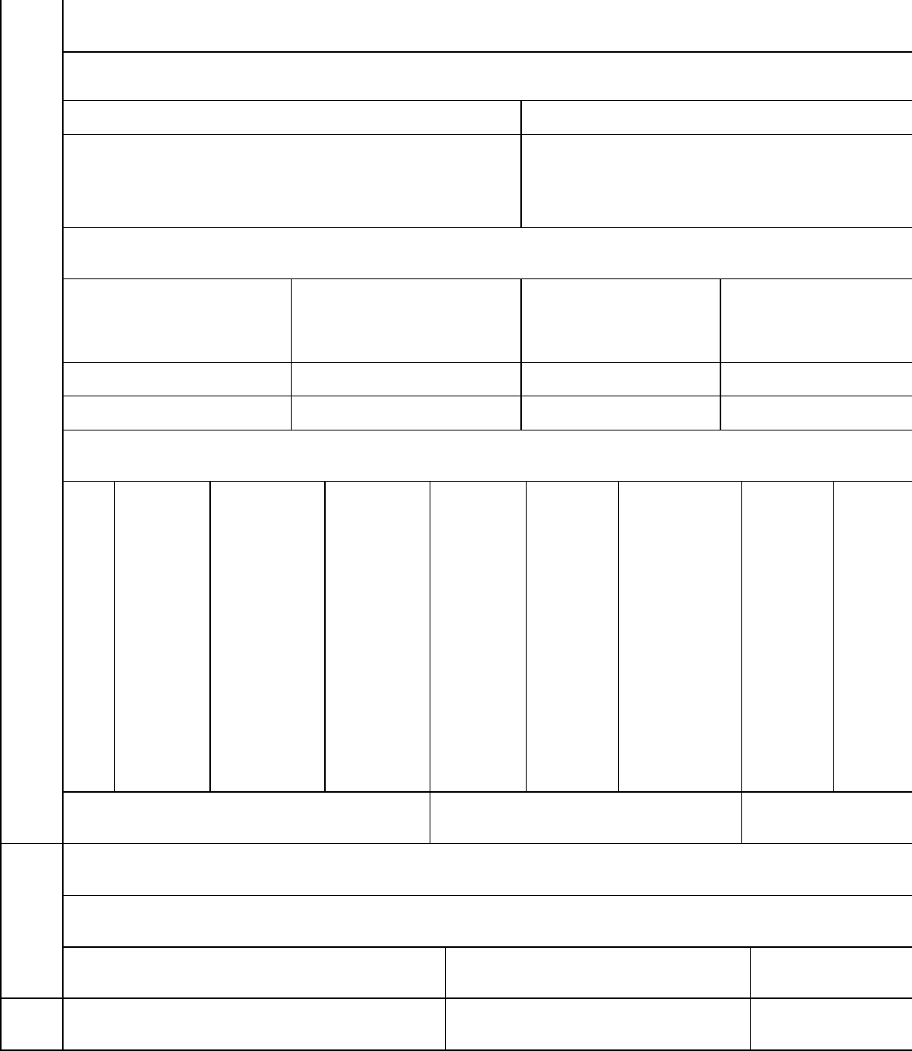
Annexures:- 1)
Miscellaneous
List of Channel Partners( HP RERA Registered Agents)
Channel Partner’s Name(Agents)
HP RERA Registration No.
i)
ii)
List of Legal cases, IF ANY
Summary of Allottees and Sale Report during the quarter
Please attach photographs of the units and facilities
2)
Place:

Date:

( Name of the authorized Signatory of the
Project) Complete Address

Annexure-(APR-3)

ANNUAL PROGRESS REPORT (APR-3)

- PARTICULARS OF THE REAL ESTATE PROJECT
Sr. Particulars Details
No.
  - Name of the Real Estate Project
  - Phase of the Real Estate Project
  - Name of the Promoter Name of the co- Promoter(s)
*Add more rows to disclose all co -promoters
  - Total area of the Real Estate Project / Phase
  - Location of the Real Estate Project

  - Type of the Real Estate Project or Phase of the Real Estate Project

  - Registration No. of the Real Estate
Project
  - Validity of Registration Certificate

  - Date of Start of the Real Estate Project
/ Phase of the Real Estate Project
  - Year for which informationis
provided
Residential Plotted Colony
ResidentialDevelopment Project
Commercial Development Project
Mix Land Use
Development Project

Valid from Valid up to

Financial Year

1.11 Detailed Annual Statement of Account by Statutory | Specimen | Annexure | -1
Auditor of the Promoter | attached
    - (Not to be submitted for those real estate projects, the completion plan of which has been approved by the competent authority )
    - (Not to be submitted for those plotted projects, in which number of plots are less than 10)
1.12 Detailed Summary of Allottees and Sale Report up to the | Specimen | Annexure | -2
end of the financial year | attached

Place: Date:

(Name of the authorized Signatory of the Project) Complete Address

ANNEXURE-1
- (Not to be submitted for those real estate projects, the completion plan of which has been approved by the competent authority )
- (Not to be submitted for those plotted projects, in which number of plots are less than 10)

ON THE LETTER HEAD OF THE CHARTERED ACCOUNTANT (WHO IS STATUTARY AUDITOR OF THE PROMOTER’S COMPANY/FIRM)

CHARTERED ACCOUNTANT’S CERTIFICATE

(ANNUAL REPORT ON STATEMENT OF ACCOUNTS)

Name of the Promoter
Name of the Real Estate Project HP RERA Registration No…………………………………………
From 01st April …………………..to 31st March ……………………
Separate Bank Account with ………………………….Bank Branch,
City…………………………………………………..
Account No……………………………………………………. IFSC Code……………………………………………………….

Subject:- Certificate of Statement of Accounts on project fund utilization and withdrawal by promoter for the period from to
……………………….
1. This Certificate is issued in accordance to the provisions as defined under point (D) of clause
(l) of sub-section (2) section 4 of the Real Estate (Regulation and Development) Act, 2016.

- I/We have obtained all necessary information and explanation from the Company, during the course of our audit, which in my / our opinion are necessary for the purpose of this Certificate.

- I/We hereby confirm that I/we have examined the prescribed registers, books and documents, and relevant records of ………………….(Promoter) for the period ended and hereby certify that in respect of the Real Estate Project titled (Name of the

Real Estate Project……………) HP RERA Registration No… located at

… as under:-
Sr. |  |  | Particulars |  | Amount
No |  |  |  |  | (Rs.)
A. | Opening Balance as on ………………..
A. | (A)
B. | Add:- Receipts during the following Quarters
 | 5. | April to June 19……………………
 | 6. | July to September 19……………..
 | 7. | October to December 19………….
 | 8. | January to March 19……………….
Sub-Total (B)
C. | Less- Withdrawals during the following Quarters
 | 5. | April to June 19…………………….
 | 6. | July to September 19………………
 | 7. | October to December 19………….
 | 8. | January | to | March | 19…………
 | Clo | Sub-Total (C)  sing Balance (A+B |  | -C)

- We certify that the above Table correctly represents the deposits in and withdrawals from the Separate Bank Account of the Real Estate Project.

- We certify that procedure and stipulations as prescribed under HP RERA in respect of deposits and withdrawal from the Separate Bank Account have been fully complied /partially complied / not complied as under:-

Details of Non–Compliance, if any


- The cost incurred during the reporting period is correctly tabulated as under:-
S.N. A.
B.
C.
Particulars
Estimated cost of the Real Estate Project Cost incurred prior to present Certificate Cost incurred during reporting period
Amount (Rs.)
D.
Total expenditure Incurred


- This is to further certify that the percentage (financial ) completion of the project is as under:-
% (Financial) | of | % | (Financial) | % | (Financial)
Completion at the start of |  | Completed during the |  | Completion | as at the
the reporting period |  | reporting period |  | end of the period.

Place: Date:

(Signature and Stamp / Seal of the Signatory CA) Name: Full Address:
Membership No. CA Unique document identification
number (UDIN No.) Mobile No. Email:

ANNEXURE -2

Sr. No. Unit No. and | Name of the | Date | of | Rate
parking no. | Allottee | booking | of main unit
if any |  |  |  | and of
 |  |  |  | parking if
 |  |  |  | allotted
 |  |  |  | (per sft.)
 |  |  |  | (Optional)

Carpet Area | Sale | value | of | Amount | Total amount
of the Unit | Unit | including |  | Collected (in %) | collected
and of | parking,
parking, if | balcony |  | &
allotted | terrace, |  | if |  | (in Rs.)
 | allotted |  |  |  | (Optional)
 | (Optional) |  |  | (Optional)


Place: Date:
9.3
Summary of Allottees and Sale Report during the financial year
*
*
*
*
*
*
* Add more rows to enter details of all bookings in the Quarter Note- 1 sqm. =10.76 sft.
9.3.1 I /we ……….(Promoter name ) have issued ……( No. of ) Allotment letters in this quarter as per the format, prescribed by the Authority.

(Signature & Name of the authorized Signatory of the Project)
Complete Address:

