ANNEXURE-1

- (Not to be submitted for those real estate projects, the completion plan of which has been approved by the competent authority)
- (Not to be submitted for those plotted projects, in which number of plots are less than 10)

ON THE LETTER HEAD OF THE CHARTERED ACCOUNTANT (WHO IS STATUTARY AUDITOR OF THE PROMOTER’S COMPANY/FIRM)

CHARTERED ACCOUNTANT’S CERTIFICATE

(ANNUAL REPORT ON STATEMENT OF ACCOUNTS)

Name of the Promoter
Name of the Real Estate Project HP RERA Registration No…………………………………………
From 01st April …………………..to 31st March ……………………
Separate Bank Account with ………………………….Bank Branch,
City…………………………………………………..
Account No…………………………………………………….
IFSC Code……………………………………………………….

Subject:- Certificate of Statement of Accounts on project fund utilization and withdrawal by promoter for the period from to
…………………………..……….

- This Certificate is issued in accordance to the provisions as defined under point (D) of clause
(l) of sub-section (2) section 4 of the Real Estate (Regulation and Development) Act, 2016.

- I/We have obtained all necessary information and explanation from the Company, during the course of our audit, which in my / our opinion are necessary for the purpose of this Certificate.

- I/We hereby confirm that I/we have examined the prescribed registers, books and documents, and relevant records of ………………….(Promoter) for the period ended and hereby certify that in respect of the Real Estate Project titled (Name of the

Real Estate Project……………) HP RERA Registration No… located at
…………………as under:-
Sr.
No
Particulars
Amount
(Rs.)
- Opening Balance as on ………………..
(A)
- Add:- Receipts during the following Quarters
  - April to June 19……………………
  - July to September 19……………..
  - October to December 19………….
  - January to March 19……………….
Sub-Total (B)
- Less- Withdrawals during the following Quarters
  - April to June 19…………………….
2.
3.
4.
July to September 19………………
October to December 19………….
January
Sub-Total (C)
to
March
19…………
Closing Balance (A+B-C)

- We certify that the above Table correctly represents the deposits in and withdrawals from the Separate Bank Account of the Real Estate Project.

- We certify that procedure and stipulations as prescribed under HP RERA in respect of deposits and withdrawal from the Separate Bank Account have been fully complied /partially complied / not complied as under:-
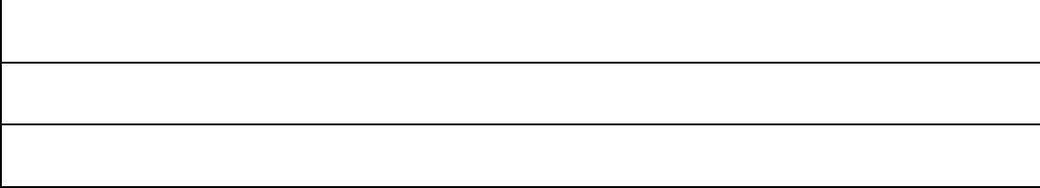
Details of Non–Compliance, if any

- The cost incurred during the reporting period is correctly tabulated as under:-

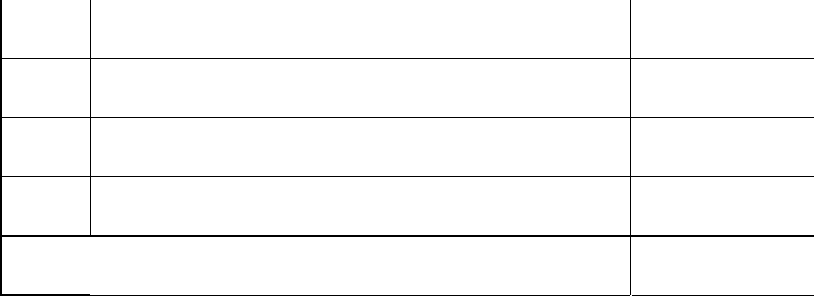
S.N.
Particulars
Amount (Rs.)
A.
Estimated cost of the Real Estate Project
B.
Cost incurred prior to present Certificate
C.
Cost incurred during reporting period
D.
Total expenditure Incurred

- This is to further certify that the percentage (financial) completion of the project is as under:-
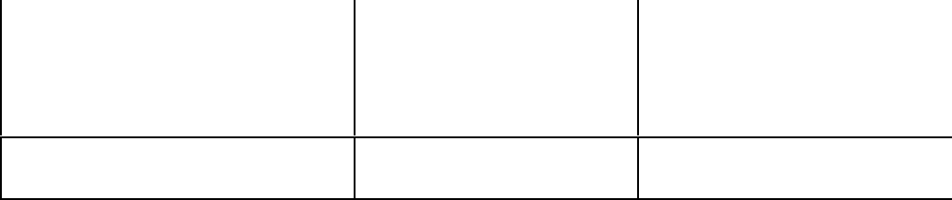
% (Financial)
of %
(Financial) %
(Financial)
Completion at the start of Completed during the Completion as at the end
the reporting period reporting period of the period.

Place: Date:

(Signature and Stamp / Seal of the Signatory CA) Name : Full Address: Membership No.
CA Unique document identification
number (UDIN No)
Mobile No. Email:

